Despite Ni’s biological importance, the marine Ni cycle appears to be lacking key components as evidenced by the imbalanced marine budget (Ciscato et al., 2018; Gall et al., 2013; Sclater et al., 1976). The budget is imbalanced in terms of mass and isotopic composition. In 1976, Krishnaswami (Krishnaswami, 1976), identified a massive mass imbalance which was confirmed in future studies (Ciscato et al., 2018; Gall et al., 2013); the sum of the sinks is estimated to be twice the sum of the sources. The identification of the mass balance spurred the use of isotopic mass balance to constrain the flux estimates. However, attempting this application revealed that there was also an isotope imbalance as well; the sinks are isotopically heavier than the sources. The combination of these imbalances points to a significant missing component (or components) rather than simply incorrect flux and isotopic estimations and measurements. A recent study may have found the solution (Little et al., 2020), but further work is clearly necessary. Once the modern marine Ni budget is balanced, we will have identified the key modern controls of marine Ni cycling and this will enable robust modelling of the marine Ni cycle, and the subsequent affects, over time.

The identified primary sources of Ni to the ocean are dust, rivers, and, potentially, a benthic flux from either the recycling of Mn oxide particles and/or their diagenetic transformation to todorokite. The estimated total Ni transported to the ocean varies from 3.68 x 108 to 1.63 x 109 mol/yr (Ciscato et al., 2018; Gall et al., 2013; Little et al., 2020). Dust, which we assume to share the isotopic composition of the continental crust, has a limited isotopic predominately range from -0.1 to +0.2‰ (Cameron et al., 2009; Gall et al., 2012; Gueguen et al., 2013) and is estimated to contribute 2% to 28% of the total marine Ni flux. Rivers are the main contributor of Ni to the oceans and make up an estimated 32% to 97% of the total marine Ni flux. The dissolved load of rivers is isotopically varied, from +0.29 to +1.38‰, with an abundance weighted isotopic composition of +0.9‰ (Cameron and Vance, 2014; Revels et al., 2021). The difference in isotopic composition of rivers and continental crust, the ultimate source of Ni to rivers, can be explained by the formation of iron oxides, a secondary weathering product of ultra mafic to mafic rocks which host the majority of the crust’s Ni. Experiments and natural observations indicate that iron oxides sorb isotopically light Ni (e.g., ferrihydrite has a fractionation of Δ60/58Nidissolved-sorbed = +0.35 ± 0.10‰) (Spivak-Birndorf et al., 2018; Wasylenki et al., 2015). The riverine particulate load may be an additional source of Ni to the ocean to help resolve the imbalance. How much Ni is retained in the particulate load versus the dissolved load and how much the particulate load could be mobilized remains unclear. What data we do have suggests that the particulate load is isotopically light compared to the dissolved load and is isotopically similar to continental crust (Revels et al., 2021). A recent effort to resolve the imbalance suggests a significant benthic source from Mn oxide redox cycling and/or diagenetic processes is of the appropriate size and isotopic composition (3.17 ± 1.08‰) to resolve the imbalance (Little et al., 2020). Thus far, the estimated input and isotopic contribution is approximately 0.6 to 2.3 x 108 mol/yr and 3.17 ± 1.08‰, respectively. However, the size of this flux and the exact mechanisms at play remain unclear and require further exploration (see section XXX for further discussion). In summary, the majority of the sources’ Ni isotopic compositions are restricted to -0.1 to 1.38‰ which are all lighter than seawater (ca. 1.3 to 1.7‰).

The deep ocean is globally homogenous, with an isotopic composition around 1.3‰ (Archer et al., 2020; Takano et al., 2017; Yang et al., 2020) while the surface ocean varies. The South Pacific (Takano et al., 2017), North Pacific (Yang et al., 2020), and South Atlantic (Archer et al., 2020) all show significant trends towards isotopically heavy values in the surface waters, up to 1.78‰, which are coupled with surface [Ni] depletions down to ca. 2 nM. On the other hand, the Indian sector of the Southern Ocean, which also displays a less pronounced, but similarly systematic surface [Ni] depletion, shows no isotopic enrichment in the heavier isotopes in surface waters (Wang et al., 2019). This discrepancy may be due to regional biology; Archer et al., hypothesize that the differing dominating species, cyanobacteria or diatoms, between south (diatom dominated) and north (cyanobacteria dominated) of the polar front results in the differing surface water isotopic compositions (Archer et al., 2020). Additional studies in other diatom dominated waters or through culture experiments could further explore this hypothesis.

Once Ni enters the ocean, its fate is a little less clear, partially because of the large isotopic variability in the dominant sinks. Previous studies have focused on Fe-Mn deposits, organic rich matter, and euxinic sediments. [I need to talk about organic rich matter and sulfides before getting into Fe-Mn isotope stuff and I need to do the percent sink thing]. Fe-Mn deposits are typically believed to represent the most significant sink; they compromise between 16% to 73% of the total estimated Ni sink (Ciscato et al., 2018; Gall et al., 2013; Little et al., 2020). However, the isotopic compositions of Fe-Mn deposits have an incredibly broad range (-1.5 to +1.8‰), which may be due to diagenetic processes (Gall et al., 2013; Gueguen et al., 2016; Little et al., 2020) (for additional discussion, see section XXX). Experimental results consistently suggest that Fe-Mn deposits should be isotopically light compared to seawater (Δ60/58NiFe oxides-aqueous = −0.35 to −0.77‰; Δ60/58NiMn oxides-aqueous −2.76 to −4‰) (Gueguen et al., 2018; Sorensen et al., 2020; Wasylenki et al., 2019, 2015). Generally, studies assign a primary Ni isotopic composition ca. 1.6‰ to Fe-Mn deposits (based on the isotopic composition of Fe-Mn crusts analyzed by Gall et al., 2013 and Gueguen et al., 2016) which is isotopically heavier than deep seawater. Organic rich matter is estimated to be the next most significant sink and make up 23 to 34% of the total estimated Ni sink (Ciscato et al., 2018; Little et al., 2020). The organic rich-pyrite fraction of samples from the upwelling sediments in the Peru Margin were found to have seawater like isotopic compositions (+1.3 ± 0.4) (Ciscato et al., 2018); however, there is significant variation within shales (δ60Ni = −0.84 to +2.50‰) which may be due to degrees of sulfidization/removal of Ni into sulfides and variable source Ni (Pašava et al., 2019; Porter et al., 2014). The primary isotopic composition of organic rich sediments is generally assigned a value of 1.2 in mass balance calculations (reflecting the Peru Margin sediments from Ciscato et al., 2018) (Ciscato et al., 2018; Little et al., 2020). Euxinic sediments appear to be a much smaller constituent of the total Ni sink, around 2.5% (Ciscato et al., 2018; Little et al., 2020), although the significance of sulfidizaiton in organic matter has not been assessed. Euxinic, sulfide rich sediments from the Black Sea have an isotopic range of +0.3 to +0.6‰ (Vance et al., 2016) and sulfidization in organic matter appears to produce isotopically lighter sediment in shales (Pašava et al., 2019).

From this data, there are two paths forward that need to be met before the Ni mass balance is resolved and before we can interpret Ni isotopic composition in the rock record. First, we must identify the primary isotopic fractionations and diagenetic mechanisms which cause the large variability observed in the two main Ni sinks, Fe-Mn deposits and organic rich sediments. Second, to reconstruct the Ni marine cycle of ancient oceans, we must find a reliable, consistent Ni record. To this end, my dissertation will pursue each of these paths. For my first project, I plan to measure the Ni isotopic compositions of primary to diagenetically altered carbonates, to determine the impact of diagenesis on the retained Ni isotopic signature of carbonates and determine the usefulness as a record of Ni. In my second project, I will experimentally determine the equilibrium fractionation of birnessite in seawater as well as todorkite, a diagenetic product of birnessite which may release Ni to the ocean during transformation. The combination of natural and experimental samples along with characterization of primary and diagenetic signatures will isolate the isotopic contributions of primary and diagenetic mechanisms. With this information, we can produce a more informed model marine Ni cycle and better predict how the marine Ni cycle may have looked different in the past.

[Maybe this should be discussed in a specific Mn oxide section?]

Manganese (hydro-)oxides, specifically hexagonal birnessite which is thought to be representative of the poorly crystalline phyllomangates found in the deep ocean, have received significant attention because of their, potentially dominating, control on Ni ocean concentrations (Peacock and Sherman, 2007a). Nickel sorbs as a surface complex and can become structurally incorporated into vacancy sites. Using their sorption complexation model of Ni-bearing hexagonal birnessite, Peacock et al., 2007 calculated the concentration of dissolved Ni in seawater in equilibrium with birnessite to be approximately 7.2 nM at pH 8.2 (Peacock and Sherman, 2007b). This is in good agreement with observed concentrations of Ni in seawater(ca. 3-12 nM) (e.g., Cameron and Vance, 2014; Sclater et al., 1976) and suggests that birnessite, or a similar Mn oxide phase, may be the dominate buffer of seawater Ni concentrations. Our knowledge of Ni’s retention or remobilization, and these processes’ isotopic fractionations, within Mn oxides is becoming increasingly complicated.

Gall et al., 2013 measured 24 surface scrapings of Fe-Mn crusts across the globe and found a variable isotopic range from 0.9 to 2.5‰ with an average of 1.67±0.8‰ (Gall et al., 2013). They did not observe any strong correlation between δ60Ni and ocean basin, oxygen saturation or Ni concentration (Fig xx), but there was a correlation between δ60Ni and distance to continental shelf, likely reflecting the contribution of isotopically lighter continental sediments. This presented the isotopic imbalance and suggested there was no isotopic fractionation associated with Ni sorption on Mn oxides. Gueguen et al., 2016 observed generally similar trends; of the four North and South Pacific Fe-Mn crusts they analyzed, they all generally overlapped with the values found in Gall et al., 2013. (1.79 ± 0.21‰ 2sd, n = 31 for North Pacific and 1.73 ± 0.21‰ 2sd, n = 21 for South Pacific) (Gueguen et al., 2016). In addition, they measured every 1 to 2 mm into the crust for ca. 20 mm and, for three of the cores, there was little isotopic variation down core. One core from the South Pacific had a systematic and dramatic drop in δ60Ni downcore (from 1.89 to 0.25‰) associated with lower Mn/Ni, suggesting that post-depositional processes associated with Mn-oxide phases may lead to alteration of the primary δ60Ni signature. Overall, Fe-Mn crust, and therefore Ni associated with Mn-oxides, appeared to isotopically reflect seawater.

In contrast, Vance et al., 2016 observed light Ni isotopic compositions associated with Mn oxides in water columns sampled within the Black Sea (Vance et al., 2016). Across the oxygen minimum, (i.e., where Mn oxide particles dissolve) the Ni isotopic composition of the water decreased significantly from ca. 1.2 to 0.8‰ while the [Ni] increased which they calculate is associated with an isotopic fractionation of ca. -4‰. They attribute this to Ni sorbed on Mn oxide being released back into the water column upon oxide dissolution at the oxygen minimum. This clearly contradicts the findings of Gueguen et al., 2016 and Gall et al., 2013. A subsequent study found both isotopically heavy and light Ni within Fe-Mn sediments; Gueguen et al., 2020 found a measured a mix of hydrogenetic Fe-Mn crusts and hydrothermal Fe-Mn deposits (Gueguen et al., 2020). Like Gall et al., 2013 and Gueguen et al., 2016, the hydrogenetic Fe-Mn crusts were isotopically similar to seawater (0.8 to 1.8‰), but, like Vance et al., 2016, hydrothermal deposits have a generally wider, isotopically lighter range (-1.5 to 1.1‰). Finally, Little et al., 2020 analyzed the Ni isotopic composition of Mn rich crusts in the Eastern Pacific, where measured Fe-Mn crust samples in that region were +1.6‰, and predominately found isotopically light sediments (−0.8 to −0.2‰) (Little et al., 2020).

Experiments exploring Ni sorption and/or incorporation into Fe oxides and Mn oxides have indicated that the solid will sorb and/or incorporate isotopically light Ni relative to solution (Gueguen et al., 2018; Sorensen et al., 2020; Wasylenki et al., 2019, 2015). Sorption onto Fe oxides such as ferrihydrite and goethite have moderate fractionations of Δ60/58Nimineral-aqueous = -0.35 ± 0.08‰ (2sd) and Δ60/58Nimineral-aqueous = -0.77 ± 0.23‰ (2sd), respectively (Gueguen et al., 2018). Nickel sorption onto Mn oxides, specifically have surprisingly large fractionation factors, considering there is no change in coordination environment or valence, of Δ60/58Nimineral-aqueous −2.76‰ to −3.35‰ depending on pH in low ionic strength solutions (Sorensen et al., 2020) and up to Δ60/58Nimineral-aqueous = -4.0‰ in high ionic strength solutions (Wasylenki et al., 2019), which exactly matches the calculated fractionation of Mn oxide dissolution in the Black Sea water column (Vance et al., 2016). However, Wasylenki et al., 2019 observed decreasing fractionation in longer duration (ca. 1 month) experiments that indicate equilibrium has not yet been reached.

A number of mechanisms have been evoked to explain these variations. Vance et al., 2016

experimental work exactly supports the Black Sea data. Sorenson et al.,

* + 1. Sinks
       1. Main Sink - Fe-Mn crust and nodules
          1. Peacock

Models that [Ni]SW can almost entirely be accounted for in via MnO equilibrium (or something) – pretty important sink

* + - * 1. Gall

First measurements of Fe-Mn crust

Suggest predominantly heavy compared to ocean

* + - * 1. Gueguen

Variability in Fe-Mn crust, different than Gall

* + - * 1. Vance

Discussion of other Fe-Mn stuff

Also sulfur paper MnO dissolution

* + - * 1. Sorenson paper (combine with Laura poster and salinity and duration)
        2. Clearly little consensus – hypothesis about diagenetic process of MnO resolving the Ni imbalance?

Brinessite -> todorokite or dissolution and precipitation

* + - 1. Secondary Sinks
         1. Organic Matter – Ciscato (organic-pyrite fraction)
         2. Sulfides – Black Sea paper

Not likely abundant for modern

* 1. Highlight Issues just presented
     1. Fe-Mn crust/MnO experiment issue
     2. Categorizing other potential sinks/sources to holistically identify “what is the fate of Ni out of the ocean?”
        1. Carbonates (small but relevant sink)
     3. We look at sinks only because they’re lesser studied, but also because they precipitate directly from seawater and can give us a view into the past

Writing from Draft 1

1. Framing the problem
   1. Review of studies showing Ni is out of balance concentration and isotope wise
      1. Introduction paragraph to section (?) - Maybe mention that other studies have used isotopes to constrain the cycles of other elements (Zn, Cu, for example)
      2. Present isotope data
         1. Gall study (initial recognition of problem mass balance problem)
            1. Hydrothermal and Fe-Mn crust isotope values here
         2. Vance and Cameron Heavy river and ocean’s heavy
         3. Continental explanation for heavy river’s (Laura’s fractionation experiments) but still not explanation for heavy oceans
         4. Next, vance euxinic sediment paper has a light sink, but likely not a large enough reservoir to tip the others
            1. Hinting at issues with Ni and MnO isotope stuff
         5. Next, Ciscato analyzed organic rich sediments and “re-presented” the mass balance equation, with isotopes this time.
      3. Missing component (include calculations of the size and isotopic composition)
         1. Sources are better known
            1. ???? hydrothermal fluids maybe, but I feel like Gall’s argument is pretty convincing
            2. Hydrothermally altered crusts (what is the net Ni going in and out?)
         2. sinks
            1. Fe-Mn crust/MnO experiment issue
            2. Carbonates (small but relevant sink)

The current model of the marine Ni cycle is woefully uninformed as best evidenced by the massively imbalanced modern marine Ni budget. The best-yet modeled marine Ni budget estimates Ni marine sinks (xx Ni mol/year) are two times greater than the sources (xx Ni mol/year). The main sources of Ni are the most well characterized. Continental dust and rivers are believed to be the main contributors, with XX x 108 Ni mol/year. The main sinks are less well defined, but Fe-Mn crusts are believed to be the most significant single sink, removing an estimated XXX x 108 Ni mol/year. Pelagic sediments which comprise pelagic clays, siliceous oozes, and carbonaceous oozes, are less well studied but are estimated to cumulatively make up an estimated XXXX x 109 Ni mol/year. If this model is an accurate representation of the marine Ni cycle, the ocean Ni concentration would be rapidly depleting. Subsequently, the abundance of marine life sensitive to Ni fluctuations, such as foraminifera and phytoplankton, would be severely affected. No evidence exists for such a scenario. Therefore, the model is likely an inaccurate representation of the marine Ni budget.

To correct the model, the underlying problem must be identified. Possible causes for the imbalanced model include (1) inaccurate flux estimates, (2) unconsidered fluxes or (3) a combination of the two. Inaccurate flux estimates are a potential reason for the inaccurate model because of the difficulty in obtaining accurate fluxes. Many assumptions are made when estimating global fluxes. Even with the best efforts, direct measurements of fluxes have large uncertainties and ranges. For example. Fe-Mn crust Ni sink flux range covers an order of magnitude in Ciscato et al., 2018. Some potential sources and sinks have been dismissed because of assumptions about their importance. For instance, carbonates have not been explored in detail as a source (through dissolution) or sink (through precipitation) and yet it covers XX% of the seafloor and has a sizeable annual precipitation (XXX kg/yr) and dissolution (XXX kg/yr) [Discuss hint at missing or underappreciated fluxes such as carbonates]. Instead of attempting to obtain better flux estimates by direct measurement, the validity of the flux estimates can be evaluated by parameterizing the mass balance equation with an additional variable, δ60Ni (eq. 1). With isotope data, the Ni mass balance equation can be constrained in three dimensions (flux, [Ni], and δ60Ni) (eq. 2). Just as the Ni fluxes of the sources and sinks should balance, so should the abundance weighted isotopic compositions of sources and sink balance. This approach has been used to resolve other metal marine cycles (e.g. Zn, Tl, Cu). However, before this method can be applied, the isotopic compositions of the major fluxes, and the mechanisms the control the isotopic compositions, must be identified.

Unfortunately, the marine Ni mass balance The known major Ni sources have been isotopically characterized or their isotopic data inferred. Assuming continental dust is isotopically similar to continental rocks, dust has an isotopic composition between -0.09 to +0.37‰ (Cameron et al., 2009). An extensive study on Ni in rivers, which contribute around 32% of the total Ni source flux, determined the abundance weighted average isotopic composition to be ca. +0.8‰ (Cameron and Vance, 2014). A handful of minor sources that make up the remaining 40% of the total Ni source flux have unknown isotopic compositions, but many of them can be inferred from related data and are typically isotopically light (e.g. cosmic dust can be assumed to have an isotopic composition of meteorites, which roughly overlap with continental rocks, ground water isotopic composition can be inferred to reflect river water) (Elliott and Steele, 2017).

[insert isotopic compositions of the ocean] ?

The known major sinks, on the other hand, are much less well characterized. Organic matter has an isotopic composition XX, nearly seawater. Pelagic sediments have not been analyzed as of yet. Fe-Mn crusts have been extensively studied, but the exact isotopic composition, and what controls it, remains elusive. The first comprehensive study analyzed a suite of 24 Fe-Mn crust and nodule samples from a variety of locations and obtained a global average δ60Ni = 1.6‰, isotopically heavier than seawater. There is a large variation in their dataset δ60Ni (0.9 to 2.5‰) (fig. 2). [include Gueguen study of Fe-Mn crust and note the sotopically light anomaly of one of the cores] They did not observe any strong correlation between δ60Ni and ocean, oxygen saturation or Ni concentration. In addition, a 70 my cross section of Fe-Mn crust indicated that δ60Ni essentially remained constant across the section. This data presents an additional issue; the known sources of Ni are isotopically lighter than the sinks. There must be a missing isotopically light sink or heavy source, or the current isotopic compositions are not representative of the sink/source fluxes. To apply the isotope mass balance approach to resolve the modern marine Ni budget, the isotope imbalance must be resolved.

[insert framing for Fe-Mn crusts and carbonates]

The isotope imbalance could be caused by issues similar to the marine Ni budget (1) inaccurate or (2) missing isotopic compositions. The Ni sinks are the most opaque components of the isotope mass balance equation. The two major sinks, pelagic sediments, and Fe-Mn crust, either have no associated isotopic composition, in the case of pelagic sediments, or have a wide range of possible isotopic compositions, in the case of Fe-Mn crust. [insert line that the sources are well characterized]. [Well what about the sinks]. My research will explore the isotopic compositions of pelagic sediments, specifically carbonates, and attempt to [nail down the control on the Fe-Mn crust isotopic composition] to resolve the isotope mass imbalance.

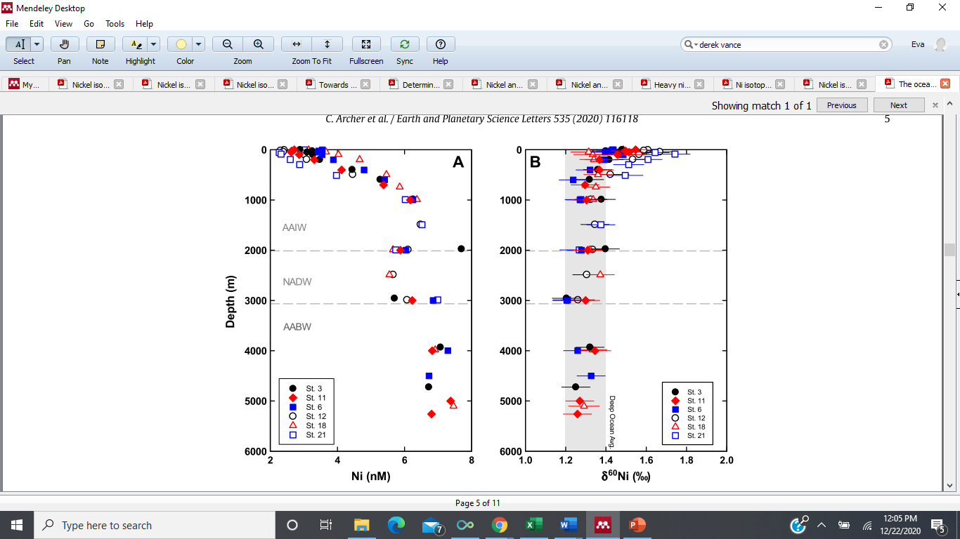Atlantic from Archer et al., 2020

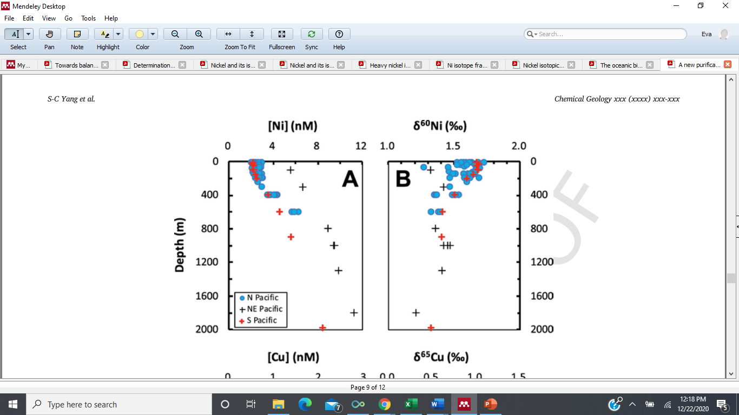Shun-chung Yang et al., 2020

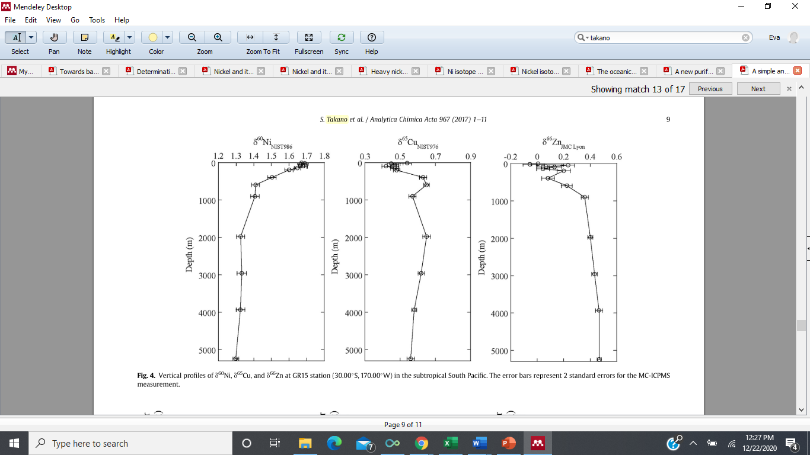Takano et al., 2017 South Pacific

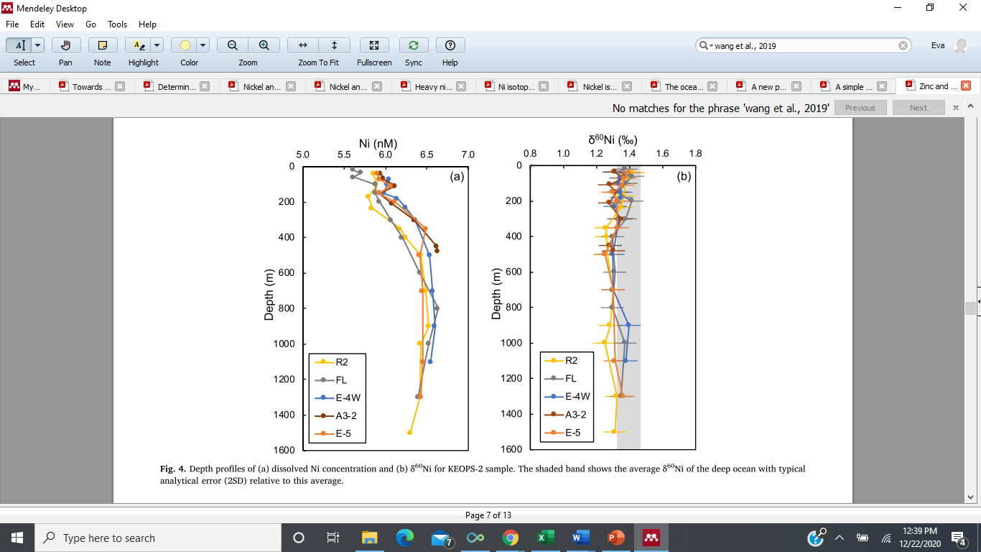Wang et al., 2019 Southern Ocean (Indian Sector)

gall et al., 2013